(HONORS) GEOMETRY NAME: _____________________
Unit 5 Lesson 2 – Use Similar Polygons BLK: _____ DATE: ___________
Prove Triangles Similar by AA
Similar Polygons: Corresponding _____________ are ________________.

Corresponding _____________ are ________________.

Scale Factor: The ___________ of all of the ________ of  ____________ figures. | 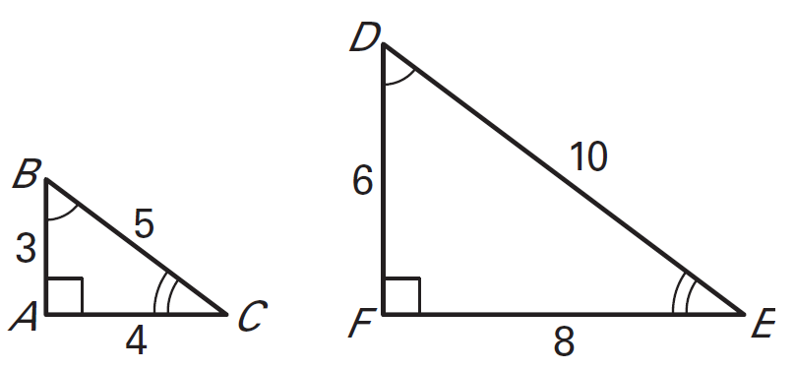

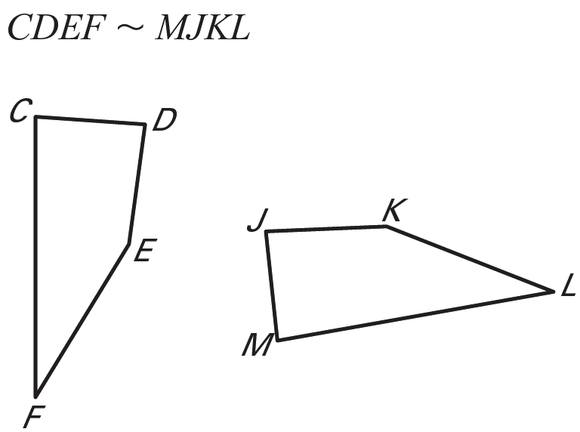
1. List all pairs of congruent angles for the figures. Then write the ratios of the corresponding sides in a statement of proportionality.
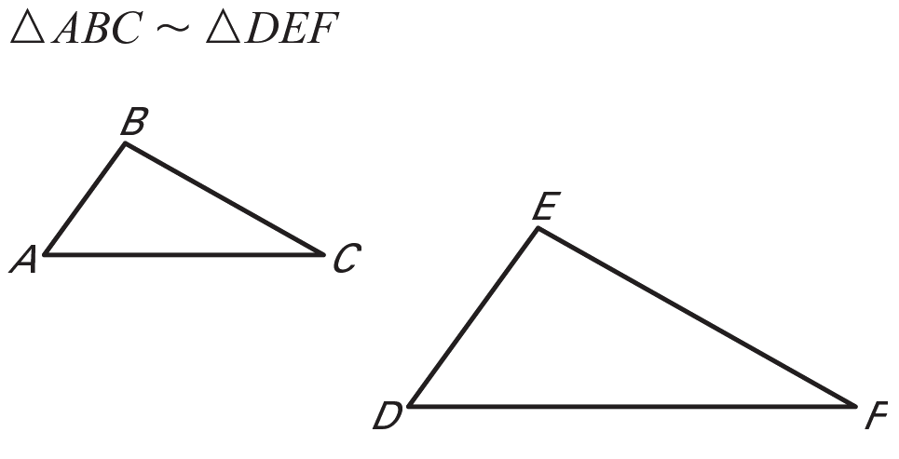

Angles: _______ _______ _______

Sides: ___________________

Angles: ______ _______ _______ _______

Sides: _________________________

2. Determine whether the polygons are similar. If they are, write a similarity statement and find the scale factor from triangle B to triangle A.
Angles Sides _______ ______
_______ ______
_______ ______

Similar: YES or NO

Similar Statement:
___________________

Scale Factor: ________
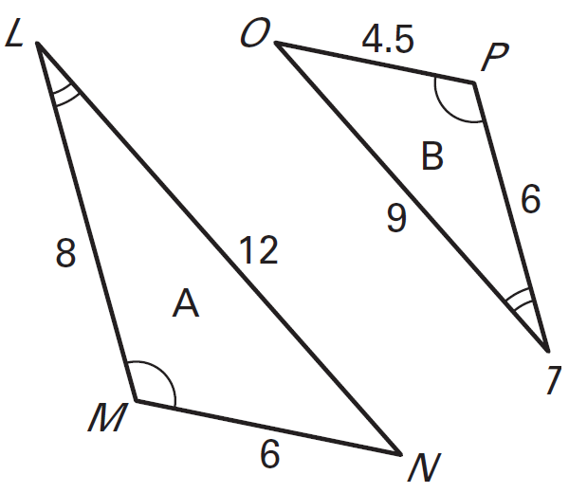

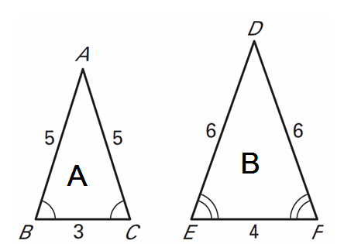
Angles Sides _______ ______
_______ ______
_______ ______

Similar: YES or NO

Similar Statement:
___________________

Scale Factor: ________

3. The polygons are similar. Find the values of the variables.

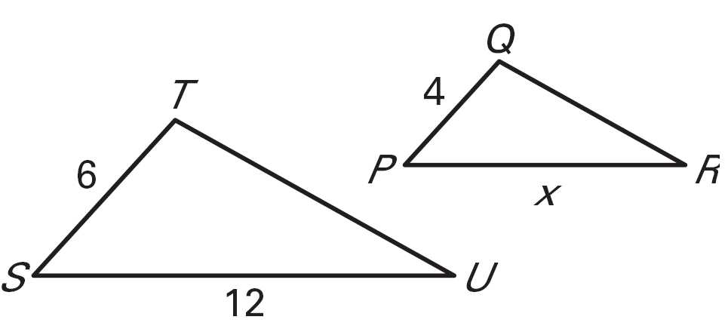
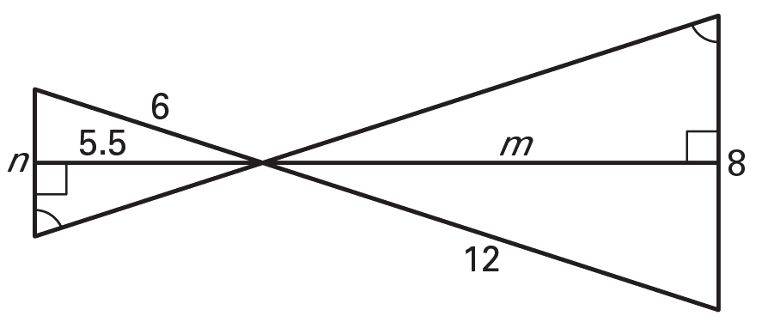

4. The two figures are similar. Find the scale factor of their sides. Then find the ratios of their perimeters. What do you notice?

SF: ______________
18
12
12
8

Perimeters: _____________
6
4

Ratios of Perimeters: If two polygons are similar, then the _____ of their ____________ is

equal to the ratios of their corresponding _______ lengths

5. The ratio of one side of a picture to the corresponding side of a larger picture is 2:7. The perimeter of the smaller picture is 16inches. Find the perimeter of the larger picture.

6. In the diagram, WXYZ ~ BCDE.
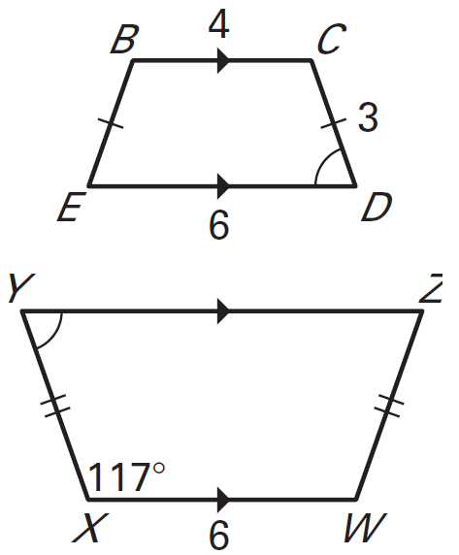
- Find the scale factor of WXYZ to BCDE.

- Find the value of XY.

- Find m∠C.

- Find the perimeter of WXYZ.

AA Similarity (AA ~)

Two triangles are ___________ if two of their _______________

angles are ______________.

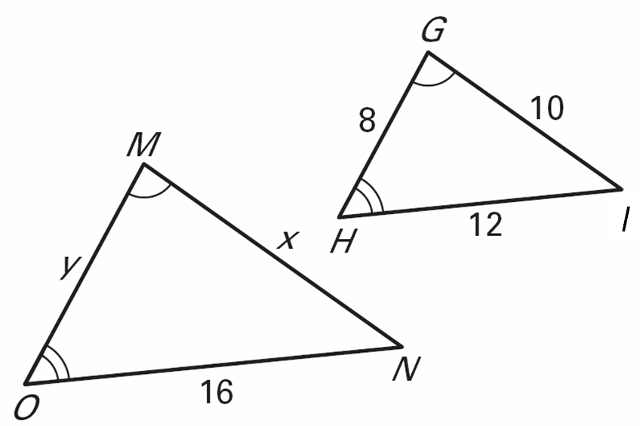
Use the diagram to complete the statement.

1. 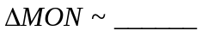

2. 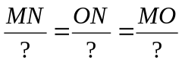

3. 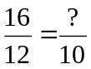

4. 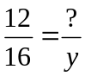

5. x = _______

6. y = _______

- Determine whether the triangles are similar. If they are, explain why and write a similarity statement.
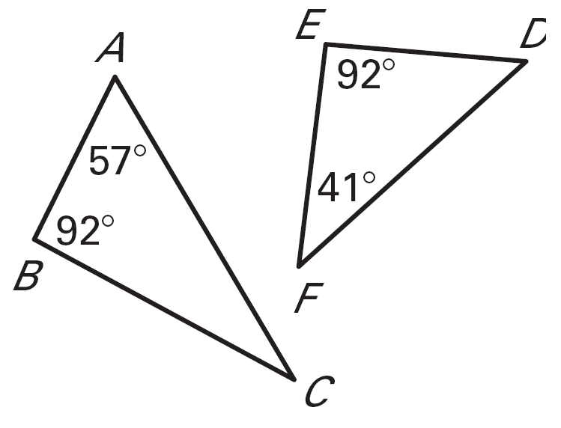
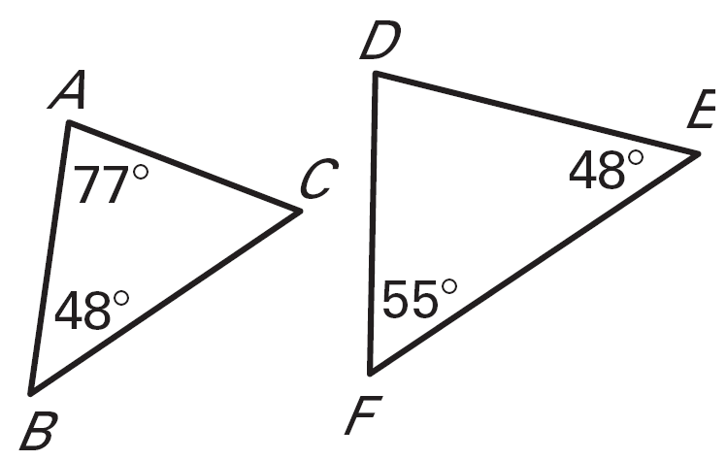
YES or NO

Postulate: __________

Similarity: __________
YES or NO

Postulate: __________

Similarity: __________

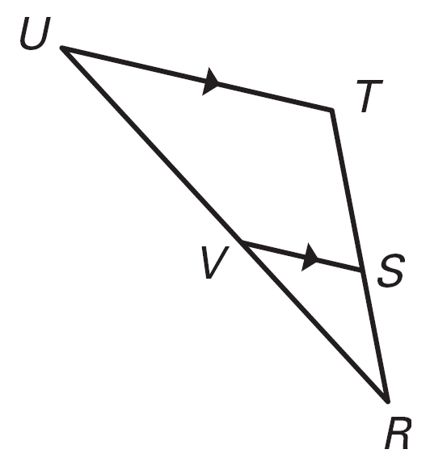
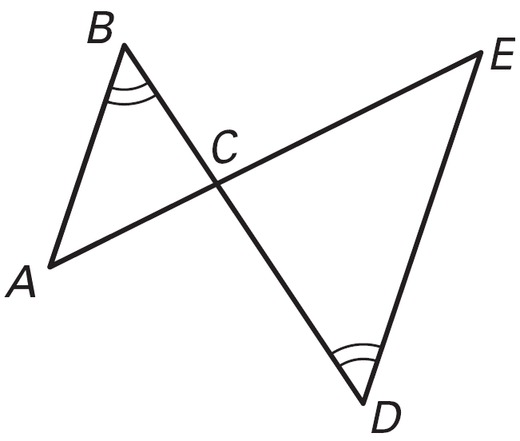
YES or NO

Postulate: __________

Similarity: __________
YES or NO

Postulate: __________

Similarity: __________

8. Find the length of BC. 9. Find m.
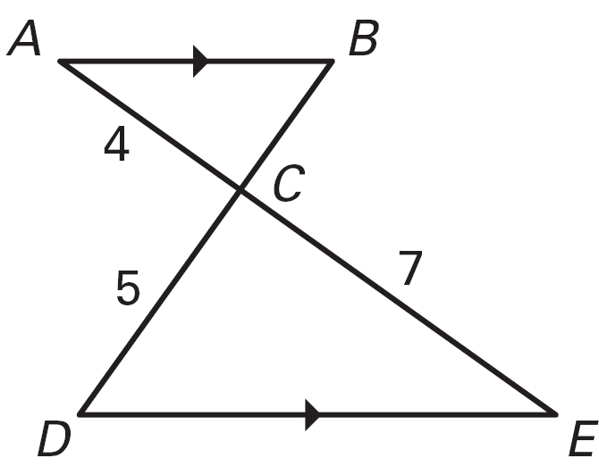
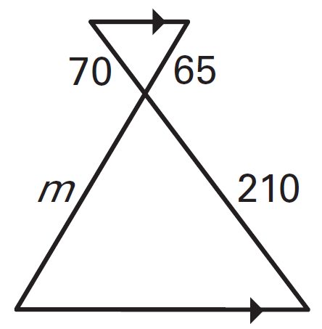

10. Find the value of x.
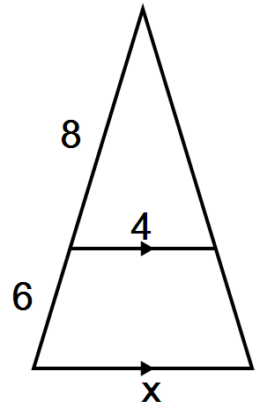
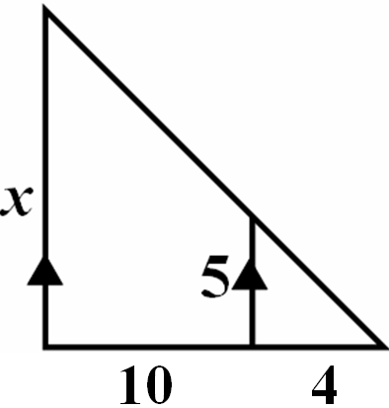

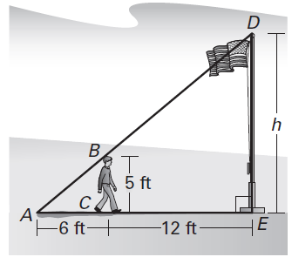
- In order to estimate the height, h, of a flag pole, a 5 foot tall male student stands so that the tip of his shadow coincides with the tip of the flag pole’s shadow.

  - Are the two triangles similar? Explain.

  - Find the height, h, of the flag pole.

